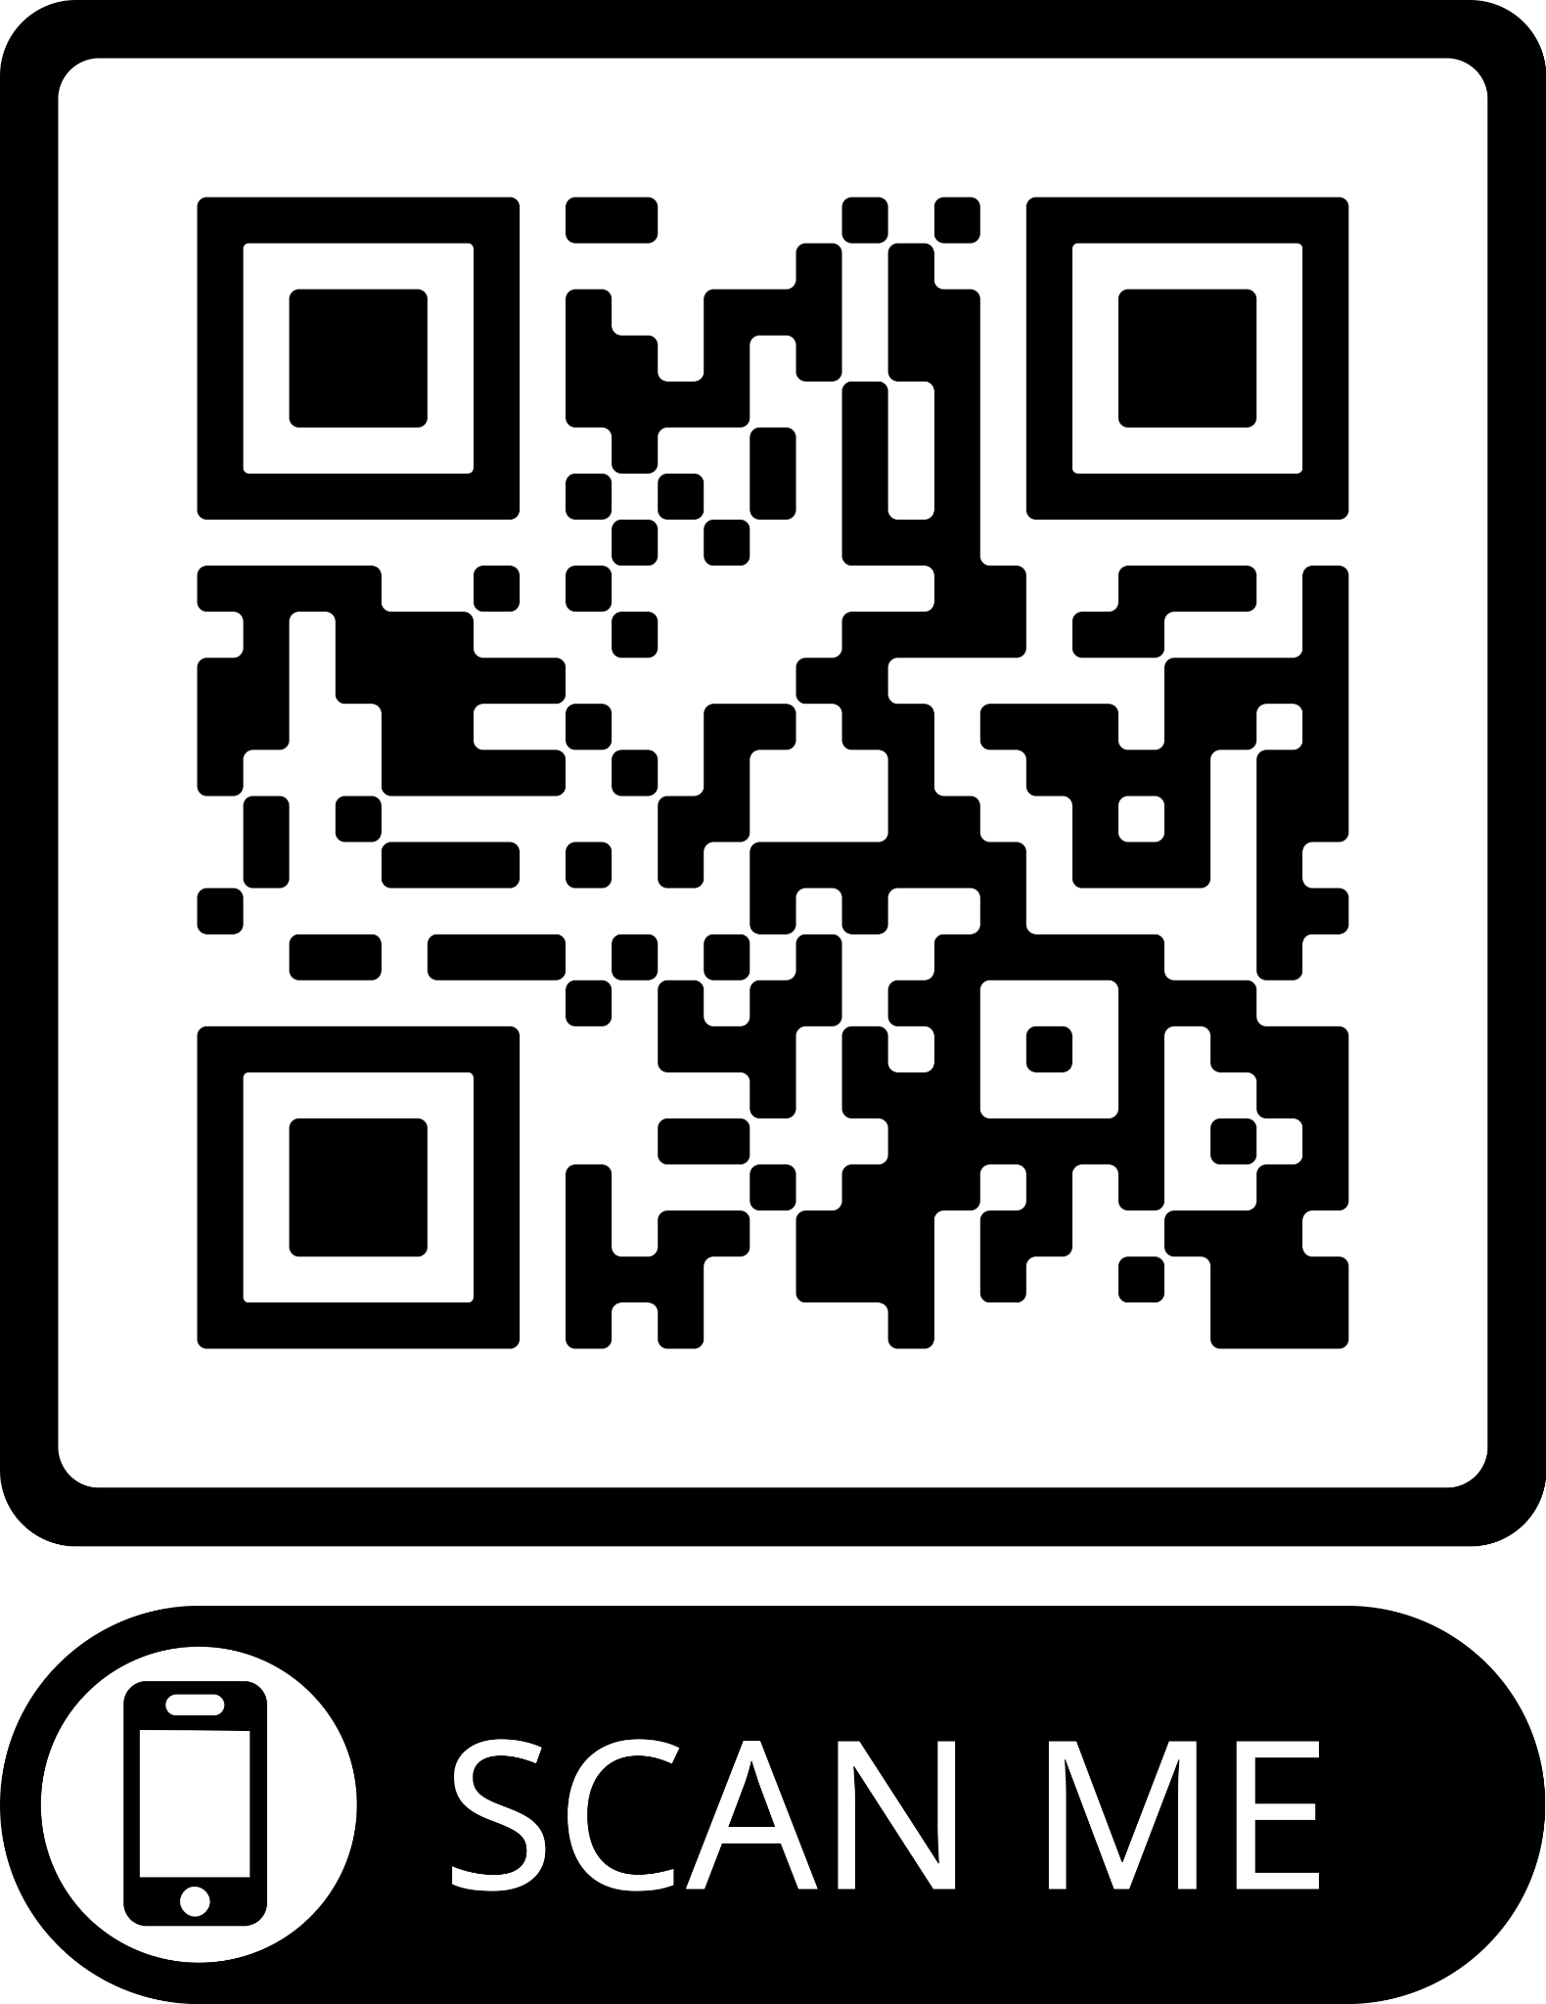

**Students: Complete this form and give to your preceptor at the end of your shift.**

**Evaluators: Use the QR code to access the Student evaluation via google forms online.**

|  |  |
| --- | --- |
| Student Name: |  |
| Date/time of shift: |  |
| Attending or resident name: |  |
|  |  |
| Cases seen: |  |
|  |  |
|  |  |
|  |  |
|  |  |
|  |  |
| Procedures done: |  |
|  |  |
|  |  |